Create table passenger with following fields

Pnr No

Ticket No

Name

Age

Gender

Contact No

Insert values into the table

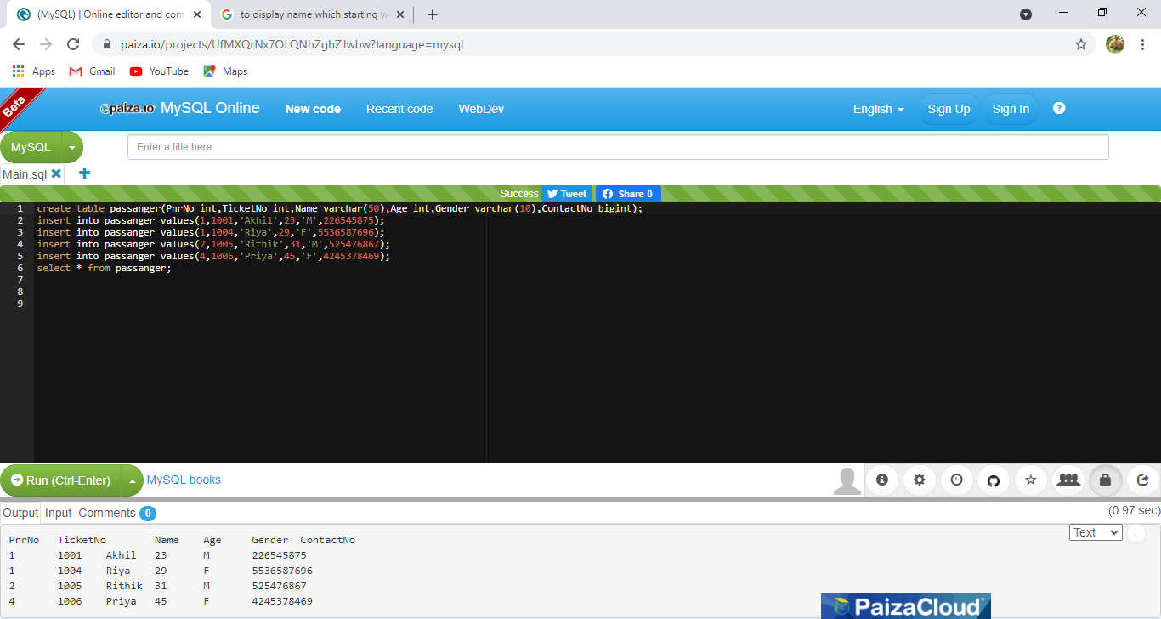

Unique PnrNo of passengers

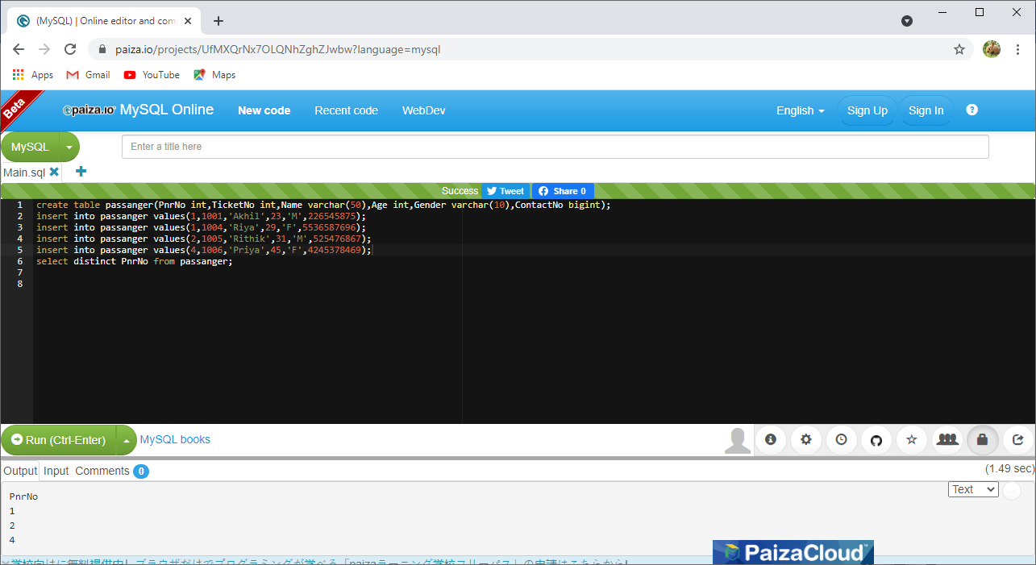

Display name of all male passengers

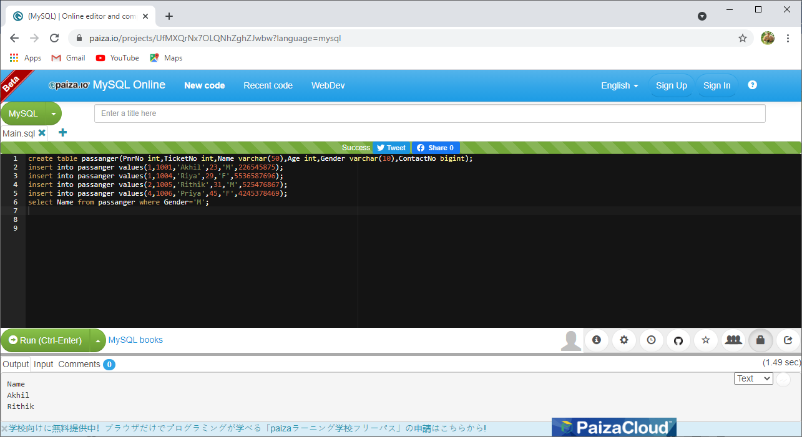

Select name of passenger whose age between 29 and 45

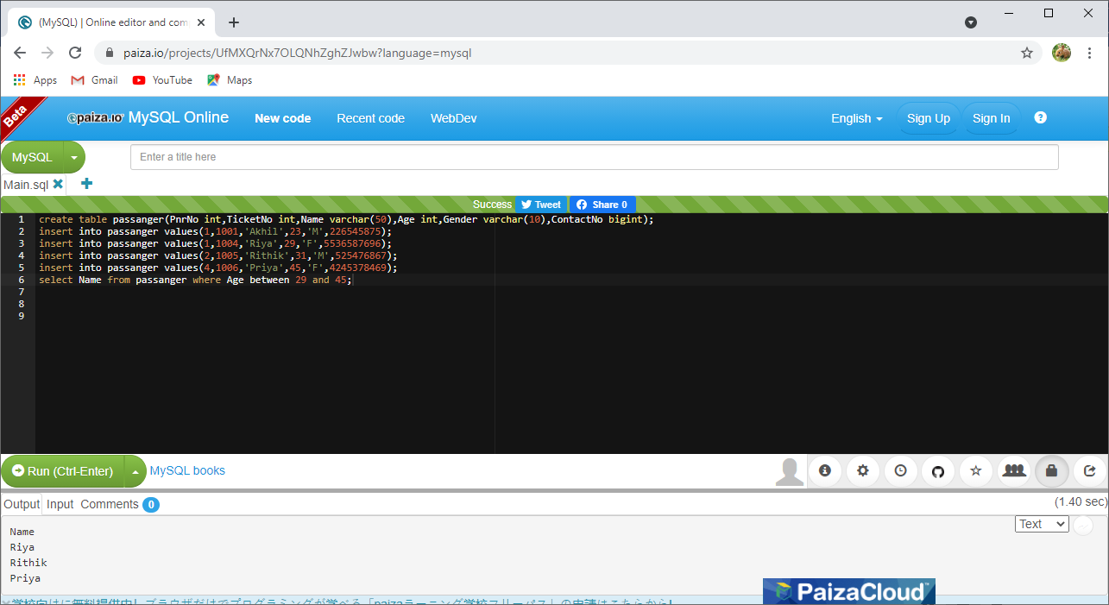

Display name of passenger whose name start with R

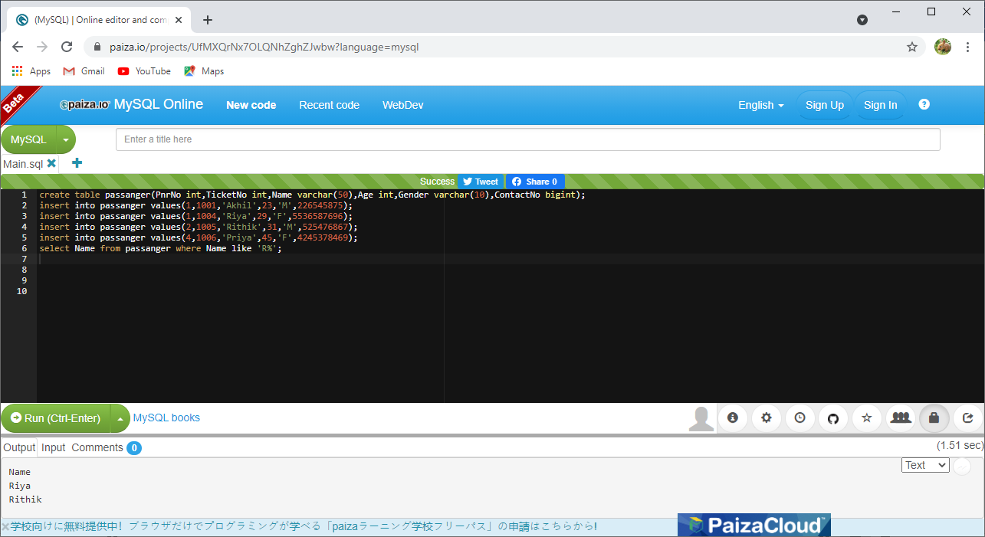

Display the sorted list by name

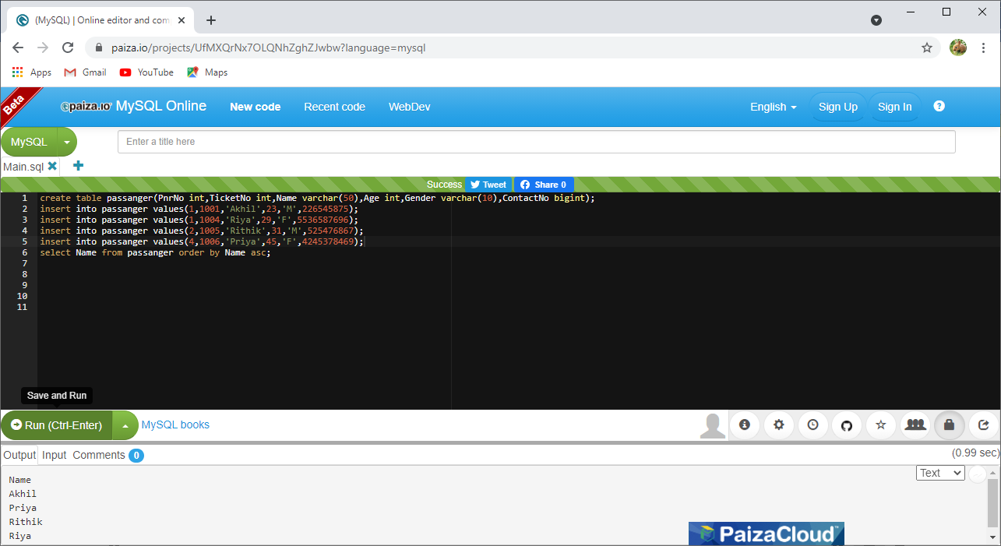

Display the total number of passengers

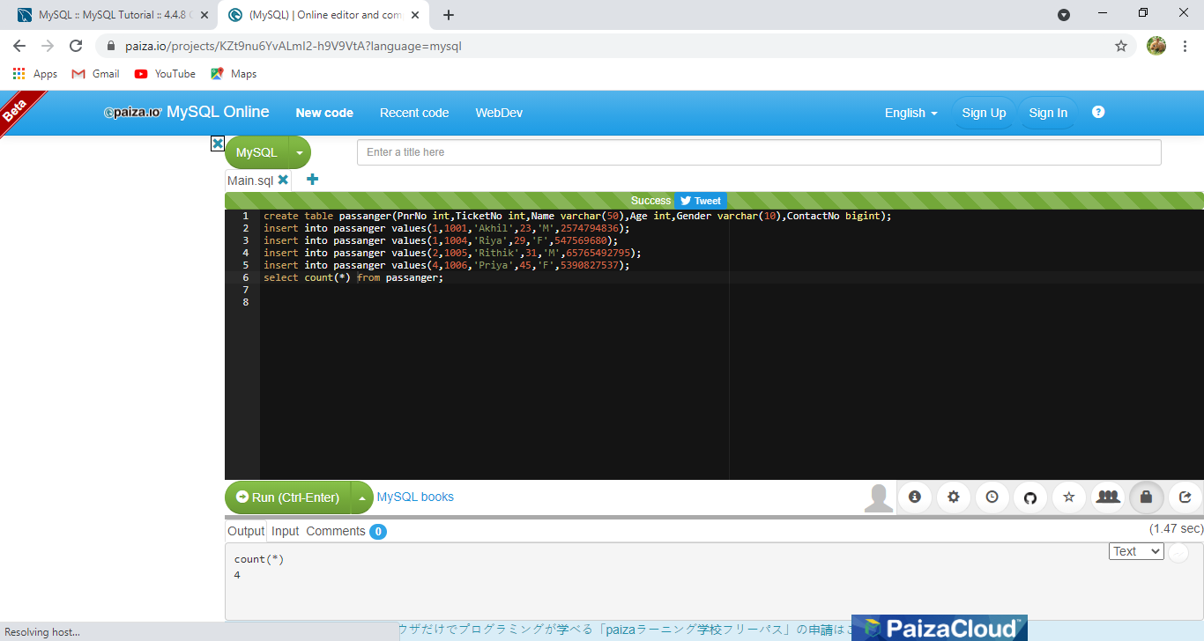

Find minimum and maximum age of passengers

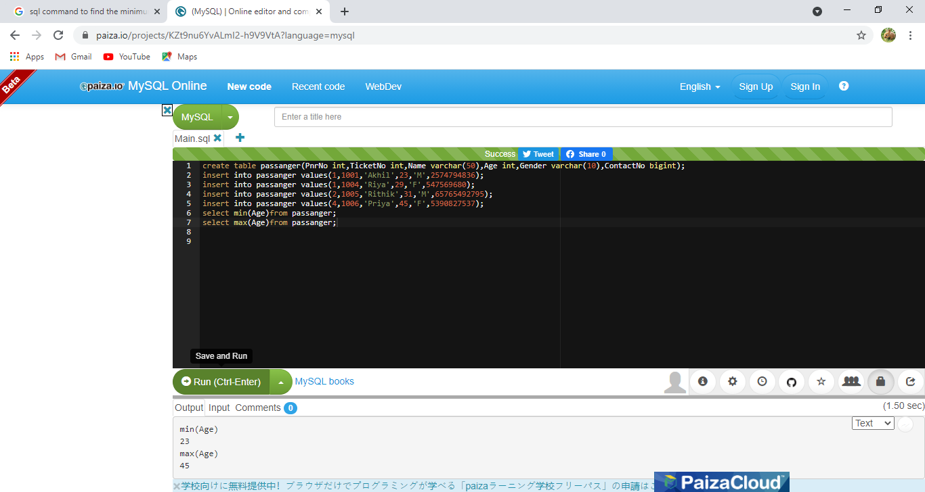

Find sum and average of age of passengers

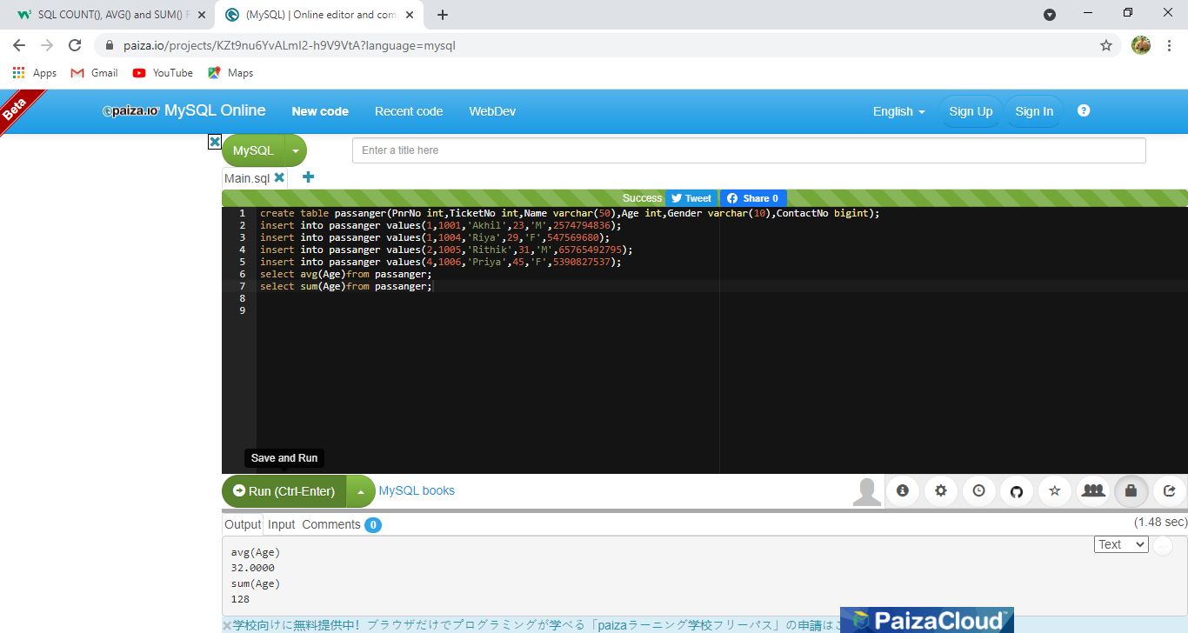

Find the ticket no of passenger whose name start with r and ends with n

